1.Priority

|  |  |
| --- | --- |
| Name of big stories | Priorities |
|  |  |
|  |  |
|  |  |
|  |  |
|  |  |
|  |  |
|  |  |

2. New Big story and small stories (Staff Management)

Big story: Staff Management:

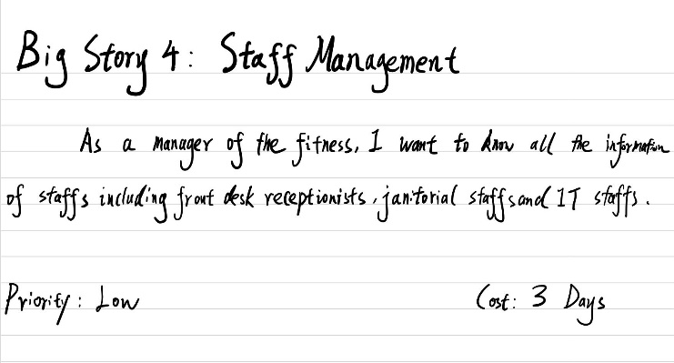

Small Story1:

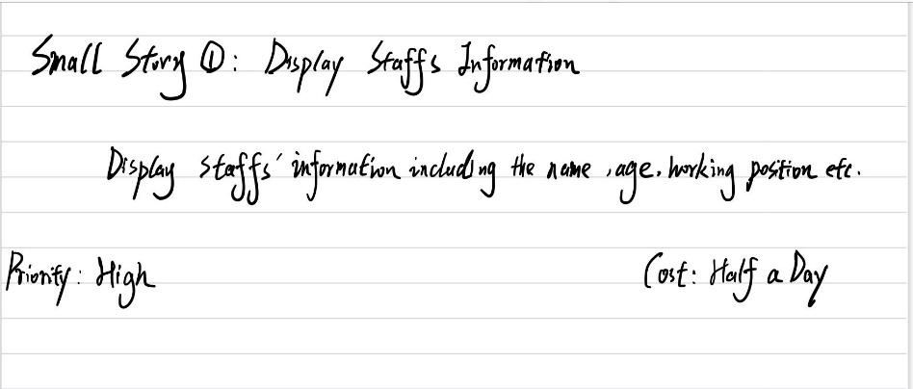

Small Story2:

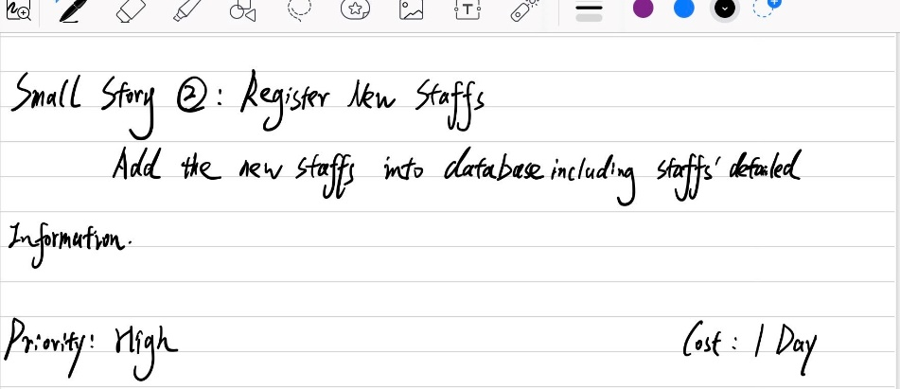

Small Story3:

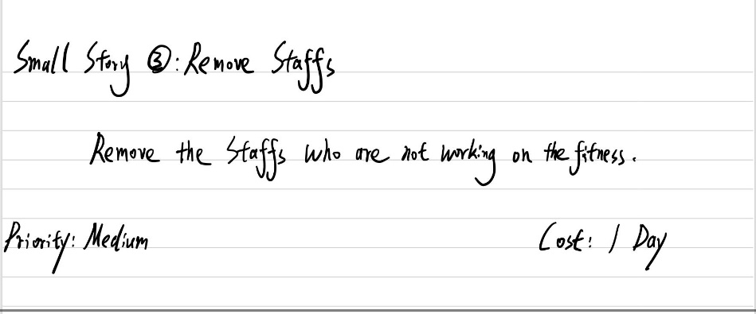

Small Story4:

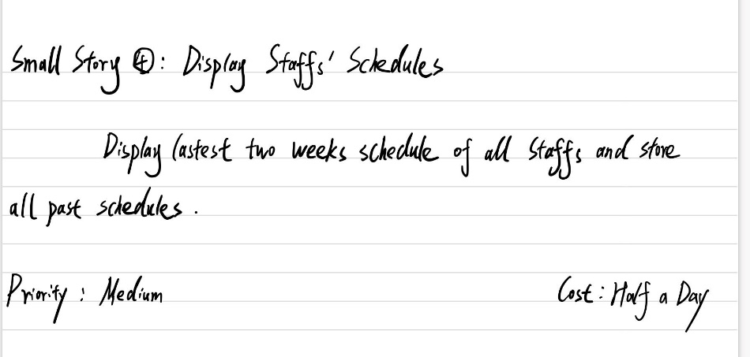

3. Revise story

1.Removing the remove function in the small story “Register new Membership”.

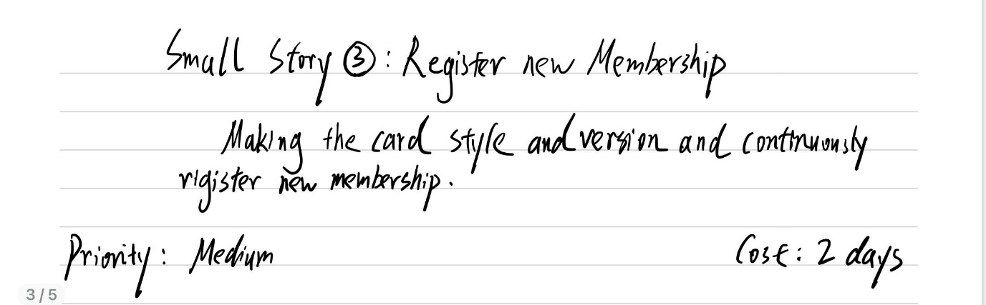

2.Adding two new small stories “Membership Cancelations” and “Types of Membership”of big story “Modify Membership” based on the requirement of client team

